**MARKET ANALYSIS**

Nigeria’s population is estimated at 186 million and is growing at 3 percent annually, with more than half of population under 30 years of age. The size and composition of Nigeria’s population makes it a vibrant health sector opportunity. Yet, government is incapable of fulfilling its obligations to the sector, thus placing a huge burden on the citizenry. Over the past decade, less than 7 percent of Nigeria’s annual budget has been allocated to healthcare. In 2018, the Federal Government has allocated N340.45 billion, which will account for representing 3.9 percent of the N8.6 trillion expenditure plan for the fiscal year.

In 2017, the amount was N304 billion representing 4.6 percent of the total budget. It is for this reason that the National Health Insurance Scheme was passed into law in May 1999 and the NHIS Act became fully operational in 2005 when the public sector aspect of the regulation was enacted. Despite the NHIS Act, only an estimated 5 to 6 million people out of the total Nigerian accounting for less than 5 percent of the populace are covered by health insurance.

With about 60 Health Maintenance Organisations (HMOs) operating from approximately 600 branches nationwide, the health and managed care market can be described as emerging. Overall, the Industry employs over 2,000 employees and provides health insurance services via a network of over 1,200 healthcare providers across the country. The Industry size, in terms of revenues, is estimated to be over N300 billion.

There is room for much growth in this Industry as a result of our population size and growing MSME and informal sector.

All that is required is for the policy makers to provide the much needed reforms and strategic actions to the sector and the Industry will expand significantly.

Overall, the healthcare industry in Nigeria is one of the most critically important and crucially fundamental sectors to any economy.

**Nigeria Demographics - 2019 Estimates**

In 2020, Nigeria's population was estimated to amount to 206 million individuals. Between 2016 and 2020, the number of people living in Nigeria regularly increased at a rate above two percent. In 2020, the population grew by 2.58 percent compared to the previous year. Nigeria is the most populous country in Africa. In addition, the whole African continent records the highest growth rate in the world.

**Growth Rate**

**Distribution by age**

**Poverty head count rate by States**

In 2019, the Nigerian states of Sokoto and Taraba had the largest percentage of people living below the poverty line. The lowest poverty rates were recorded in the South and South-Western states. In Lagos, this figure equaled to 4.5 percent, the lowest rate in Nigeria. An individual is considered poor in Nigeria when has an availability of less than 137.4 thousand Nigerian Naira (roughly 361 U.S. dollars) per year. In total, 40.1 percent of population in Nigeria lived in poverty.

**In percentages**

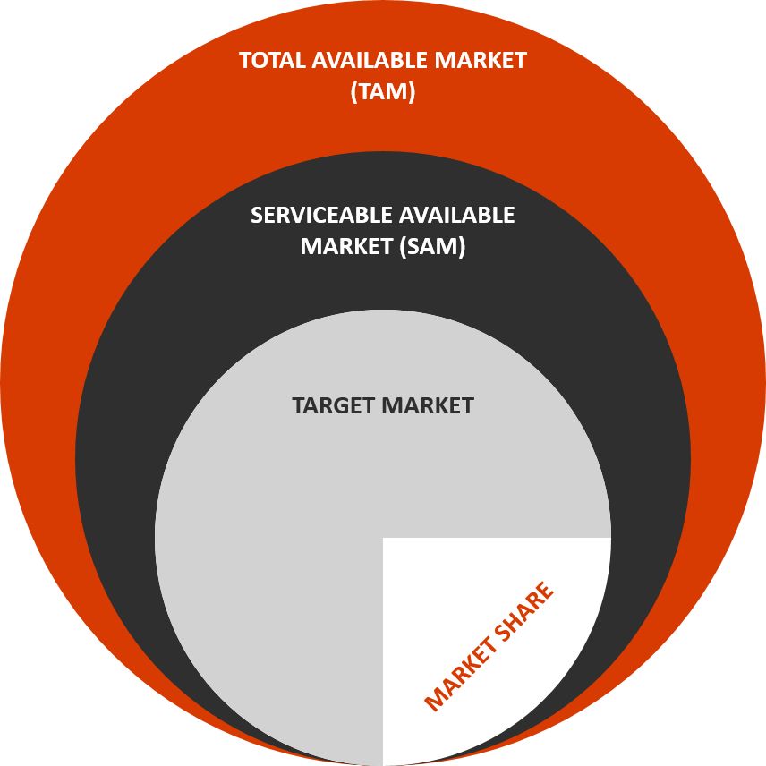**Market Segmentation:**

We need to figure out there market segment and that would help us get the following…

* **Total Available Market (TAM):**
* **Serviceable Available Market (SAM):**
* **Target Market:**
  + - Staff of higher institutions in major cities
    - States and local government staff
    - Bank and insurance companies
    - Highbrow schools
    - Private companies with large number of staff
* **Target Areas**
* States’ capital
* Large cities
* Preference to cities with low poverty rate (see the poverty rate chart)
* **Competition Analysis:** Top 10 Competitors Analysis
  + Hygeia HMO Limited - This organization was established 1986. It's one of top health insurance companies in Nigeria. According to the National Health Insurance Scheme, this company was licensed in 2005. It has various health insurance plans which are quite affordable for a lot of people:
    - * Individual plan;
      * Small Families plan;
      * Large Families plan;
      * Medical Evacuations plan;
      * Senior Citizens plan.
* Total Health Trust Limited - It's the largest health insurance organization in Nigeria. It has over 300,000 members. This company was established in 1998. Since then, it has grown to become one of the largest players on the market. Total Health gives you access to over 500 private clinics. The main office building is located in Lagos. It has eleven regional offices across the country. This organization is backed by the Liberty Group of South Africa.
* Integrated Healthcare Limited - It is also one of the health insurance companies top 10 Nigeria. This company offers an IT approach to medical care. Integrated Healthcare Limited was established in 2000. The head office of the company is located in Garki. One of the main features of the company is the 24-hour call center which can be reached by any patient.
* AIICO Multi-Shield Nigeria Limited This company was registered as an HMO in Nigeria in 1997. It was the first company registered according to the National Health Insurance Scheme. It offers a number of health insurance plans including: The following are the Evacuation plans;
  + - Magnum;
    - Super-Executive;
    - Executive;
      * Standard.
  + Princeton Health Limited It was established in 1999. One of the advantages of its healthcare plans is the American Management Healthcare model. The leader of this organization is prince Olagoke Oladinni. The main services offered by the company include:
    - * Annual physical check;
      * Specialist consultation;
      * Emergency care;
      * Primary care consultation;
      * Hospital registration.
      * Princeton also offers National Health Insurance and pre-paid schemes.
  + Defence Health Maintenance Ltd - This organization is owned by the Nigerian Armed Forces and Ministry of Defence. It has over 20 branches in the country. It provides healthcare service in the military and civilian sectors.
  + Healthcare Security Limited - If you are looking for one of the best health security organizations in the country, you should take a look at Healthcare Security. This company provides unique healthcare plans. Also, they are affordable for the majority of the population.
  + Mediplan Healthcare Limited - This company was incorporated in 2000. It has very notable clients which include the Federal Ministries.
  + Clearline international Limited - It's one of the most popular insurance companies in Nigeria. It has more than 2000 partner hospitals. The Healthcare plans are affordable for a lot of Nigerians.
  + Premium Health Limited - The customer base of this company is estimated over 250,000. It's one of the most capitalized HMO in Nigeria.

**Strategic Planning Process**

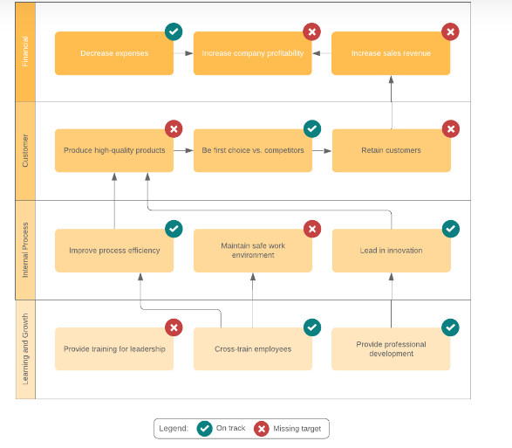

**SWOT Analysis:**

Objective: This is to review Prohealth HMO organization structure and to identify issues working against the company’s success.

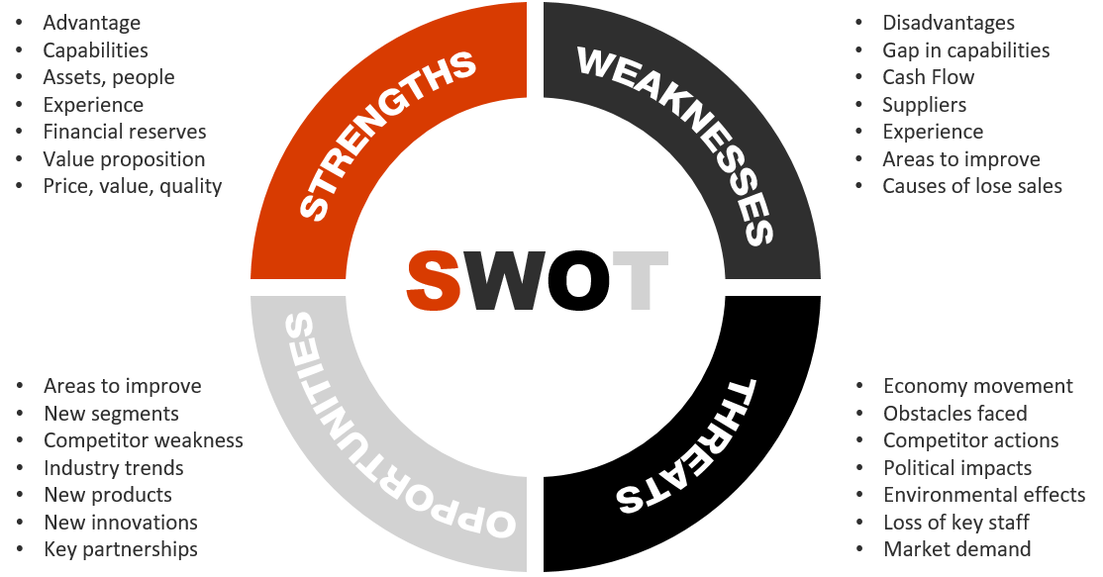

* **Strengths:**
  + Cross functional productivity
  + Value proposition
* **Weaknesses:**
  + Staffing issues
  + Evaluation complaints
  + Low morale
  + Lack of internal structure
  + Branches not properly coordinated & aligned
  + Inadequate compensation
* **Opportunities:**
  + Revised job description
  + Chance to update strategic plan
  + New segments
  + Vast market opportunity
* **Threats:**
  + Poor brand awareness
  + Strong Big 5 Competition
  + Economy movement
  + Inadequate regulation

**Force Field Analysis**

|  |  |  |  |  |
| --- | --- | --- | --- | --- |
| **Forces FOR Change** | **Score** | **Change Proposal** | **Score** | **Forces AGAINST Change** |
| *Helps in implementing change at the organization* | **4** | **Organizational Restructuring** | **4** | *Likely to face huge resistance* |
| *A first step in restructuring of the business processes* | **3** | **3** | *The cost may be too high* |
| *Support collaboration and process automation.* | **3** | **2** | *Helps many be needed in implementing change at the organization* |
| *Makes it easy for each department to work independently* | **3** | **2** | *Difficult to implement change at all levels simultaneously* |
| *Also makes it easy for each department to work* | **3** | **3** | *Difficult to select from many solutions* |
| *Restructuring of the entire organization* | **4** | **2** | *Lack of in-house expertise* |
| *Repositioning of the business teams for profit* | **4** | **2** | *May be hard to accurately measure the benefits on time* |
| **TOTAL** | **24** | **18** | **TOTAL** |